Lakeridge High School Band
Poinsettia Fundraiser
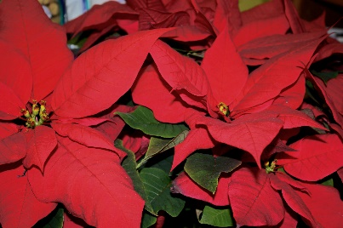
Please provide the following information:
Name ____________________________ e-mail _______________________
phone ___________________
Please make checks payable to Pacer Band. Thank you!

Size/Color | Price | Quantity | Total
6.5” red | $12
6.5” white | $12
8” red | $20
8” white | $20
TOTAL

We also accept cash. Payments and order forms are due back to Chris McCurdy, Band Director, Lakeridge HS, 1235 Overlook Drive, Lake Oswego, OR 97034 by Friday, November 9, 2018. Plants may be picked-up in the Band Room on Monday, December 10, 2018, 3:30 – 5:00.
Thanks for your support! Through your generosity, we’re able to hire educators and musicians to work with our students, purchase and maintain instruments, and participate in music festivals.
If you have any questions, please contact Christina Hardy at 503.442.7617.

