Band Poinsettia Fundraiser
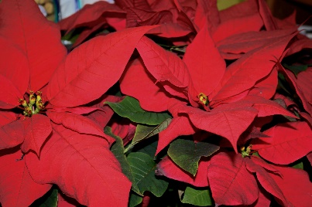

Please provide the following information:
Name ____________________________ e-mail _______________________
phone ___________________

Size/Color | Price | Quantity | Total
6.5” red | $12
6.5” white | $12
8” red | $20
8” white | $20
TOTAL

Cash and checks accepted. Please make checks payable to Pacer Band. Payments and order forms are due back to Chris McCurdy, Band Director, by Monday, November 12, 2018. Plants may be picked-up in the Band Room on Monday, December 10, 2018, 3:30 – 5:00.
Thanks for your support! Through your generosity, we’re able to hire educators and musicians to work with our students, purchase and maintain instruments, and participate in music festivals.
If you have any questions, please contact Christina Hardy at 503.442.7617.

